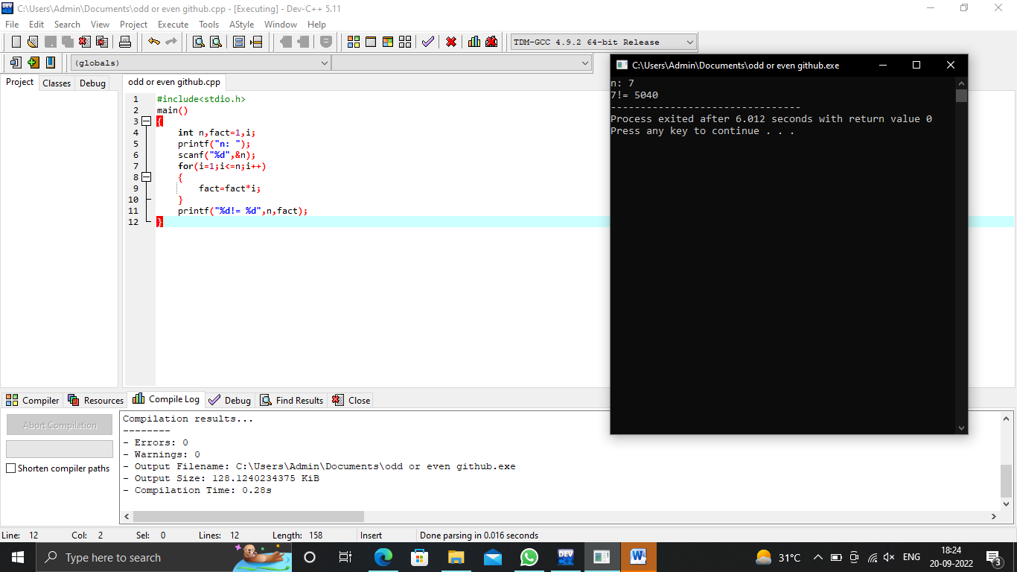

#include<stdio.h>

main()

{

int n,fact=1,i;

printf("n: ");

scanf("%d",&n);

for(i=1;i<=n;i++)

{

fact=fact\*i;

}

printf("%d!= %d",n,fact);

}